TRYHACKME LAB WRITEUP 01 / 04

Linux Logging for SOC
  - Training-room summary and evidence-aware reflection

Training reference
https://tryhackme.com/room/linuxloggingforsoc

Learning objectives
- Recognize authentication and system log sources on Linux.
- Locate relevant records with cat, less, grep, tail and journalctl where available.
- Relate log timestamps and user/process data to a SOC alert.

Concepts reviewed
Authentication, system and application logs as investigation evidence; use timestamps, users and processes to reconstruct an event.

Approach and SOC interpretation
- Identify which log or packet field directly supports a claim.
- Filter by event time and asset before drawing conclusions.
- Explain to a SOC analyst why the result could matter and how it may be validated.

Evidence and completion status
Learner reported completing this room; the supplied ZIP contains the room screenshot. Screenshot evidence is attached below.
The supplied screenshot shows the named TryHackMe room with a green completion/progress band. Exact question answers and command transcripts were not included in the ZIP.
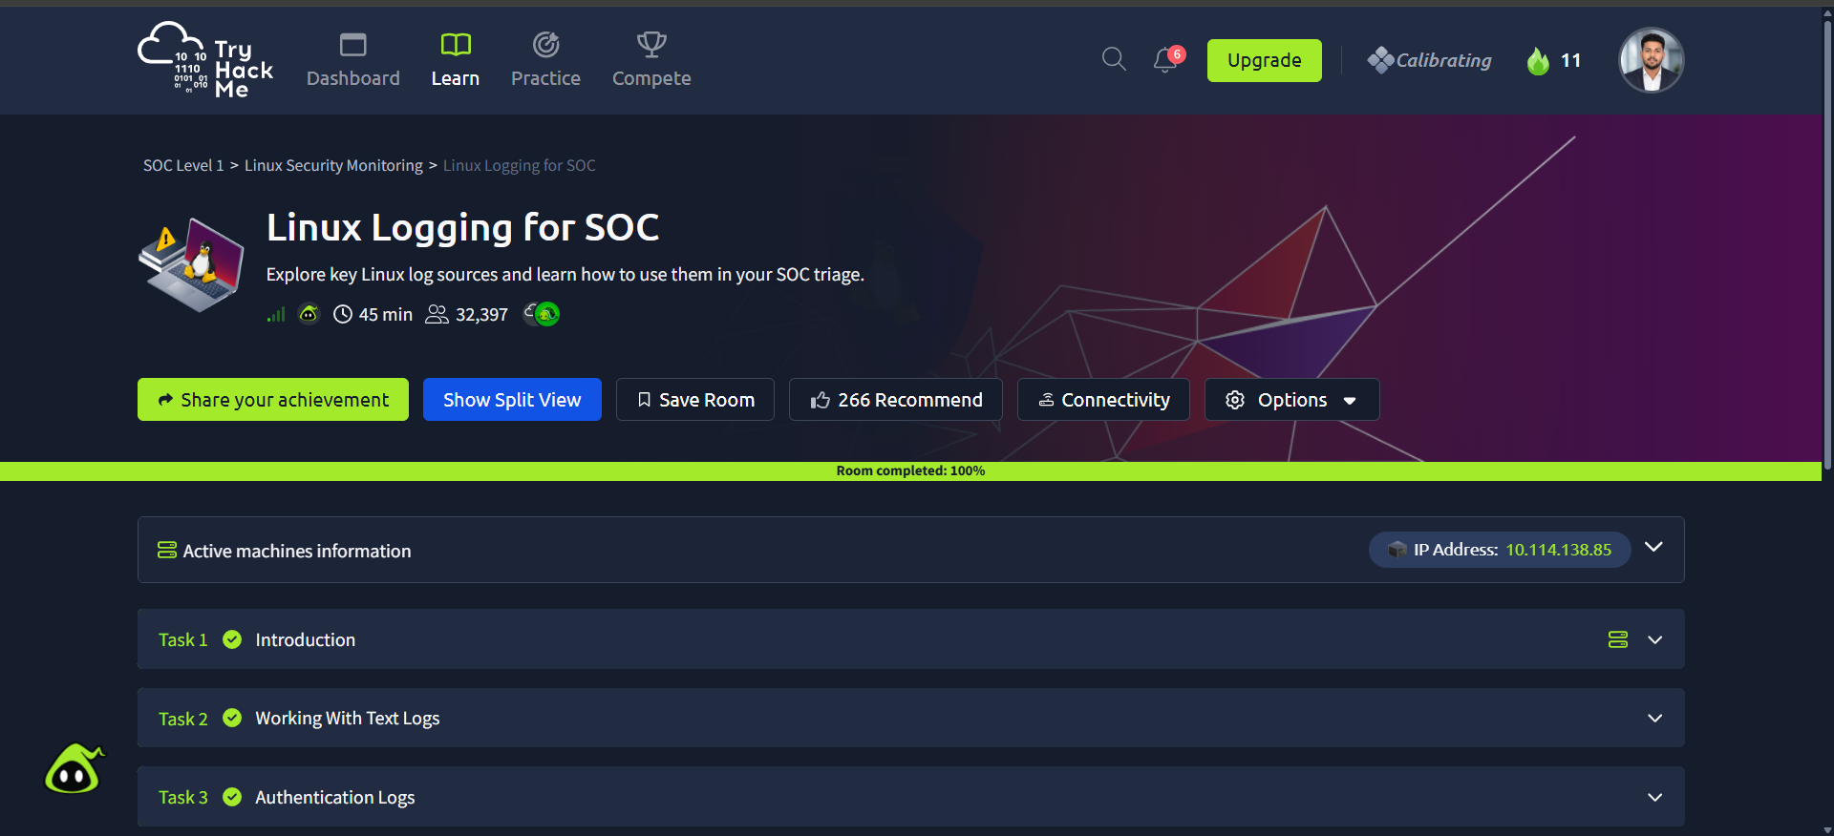
Evidence: source screenshot provided for Linux Logging for SOC

Reflection / relation to the lab
This room connects to the Windows Sysmon, Linux auditd and Snort exercises documented in the Week 3 practical report. Specific room questions, answers and typed commands are intentionally not claimed without source evidence.

